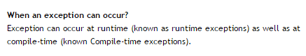

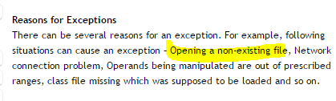

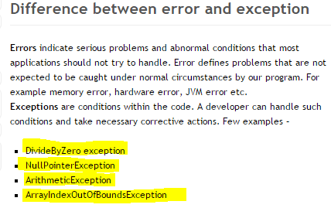

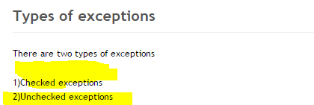

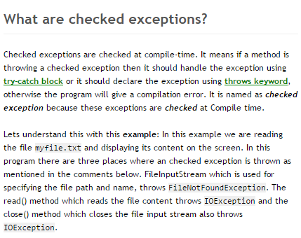

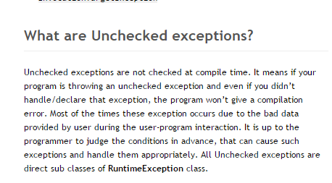

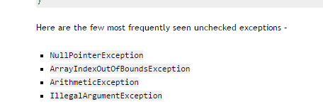

**StateElementException OR DOM is not attached**

The problem you are probably facing is that the method returns the right (and valid!) element, but when you're trying to access it a second later, it is stale and throws.

This usually arises when:

1. You click something that loads a new page asynchronously or at least changes it.
2. You immediately (before the page load could finish) search for an element ... and you find it!
3. The page finally unloads and the new one loads up.
4. You try to access your previously found element, but now it's stale, even though the new page contains it, too.
5. E.g If you are trying to Click on link, that taking you to new page. After that navigating back and clicking on other links. They below code may help you.